Project 1 — Customer Churn Analysis
Why start with this project?
Customer churn is a concrete, high-impact problem that businesses care about every day. This project is a great first choice because it combines real-world business questions with practical data skills: cleaning messy data, exploring customer behavior, building actionable KPIs, and turning findings into recommendations that managers can use to reduce churn. It’s an ideal showcase of both technical ability and business thinking.

Project overview
Business problem
A telecom provider is experiencing customer loss and needs to understand what’s happening. Management wants answers to:
- Why are customers leaving?
- Which customer segments are most likely to churn?
- Which plans or services have the highest churn rates?
- What steps can the company take to reduce churn?

My role
Analyze customer behavior using the Telco dataset, extract insights, build visual dashboards, and provide business recommendations to help reduce churn.
Dataset
- Source: IBM Telco Customer Churn Dataset (Kaggle)
https://www.kaggle.com/datasets/blastchar/telco-customer-churn
- File to use: WA_Fn-UseC_-Telco-Customer-Churn.csv

Project workflow
- Data collection
- Create SQL database
- Data cleaning
- Exploratory data analysis
- KPI generation
- Power BI dashboard
- Business recommendations

Data understanding
Key columns and what they mean:
Customer information
- customerID — unique identifier for each customer
- gender — customer gender
- SeniorCitizen — whether the customer is a senior (binary)
- Partner — has a partner (Yes/No)
- Dependents — has dependents (Yes/No)
Service information
- PhoneService — whether they have phone service
- InternetService — type of internet service (DSL, Fiber optic, None)
- OnlineSecurity — whether online security add-on is subscribed
- TechSupport — tech support subscription
- StreamingTV — streaming TV subscription
Account information
- tenure — months the customer has been with the company
- Contract — contract type (month-to-month, one year, two year)
- PaymentMethod — payment method used
- MonthlyCharges — monthly billing amount
- TotalCharges — total billed amount to date
Target column
- Churn — whether the customer left (Yes/No)
SQL Data Creation & Analysis
- Load cleaned data into a relational database to enable repeatable queries and aggregated reporting.
- Create tables for customers, services, and account metrics, and write SQL queries to compute churn by customer segment, plan, tenure group, and payment method.

Step | SQL Query | Output
1. | Create database  CREATE DATABASE customer_churn; | 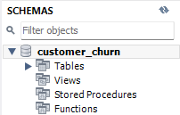
2. | Using this Database  USE customer_churn;
3. | Import CSV file through  “Table Data Import Wizard”
4. | Verifying Import  SELECT COUNT(*)  FROM telco_customers; | 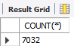
5. | Checking Total Customers  SELECT COUNT(*) AS Total_Customers  FROM telco_customers; | 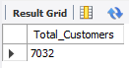
6. | Checking Total Churn Customers  SELECT COUNT(*) AS Churned_customers  FROM telco_customers  WHERE Churn='Yes'; | 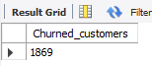
7. | Checking Churn Rate  SELECT  ROUND(  SUM(CASE WHEN Churn='Yes' THEN 1 ELSE 0 END)  *100.0/  COUNT(*),  2  ) AS Churn_Rate  FROM telco_customers; | 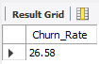
8. | Checking Churn by Customer’s Contract  SELECT  Contract,  COUNT(*) AS Customers,  SUM(CASE WHEN Churn='Yes' THEN 1 ELSE 0 END) AS Churned  FROM telco_customers  GROUP BY Contract; | 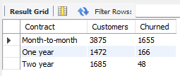
9. | Average Monthly Charges  SELECT  AVG(MonthlyCharges)  FROM telco_customers; | 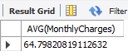
10. | Top Payment Methods  SELECT  PaymentMethod,  COUNT(*)  FROM telco_customers  GROUP BY PaymentMethod; | 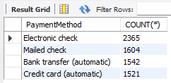
11. | Tenure Analysis  SELECT  CASE  WHEN tenure <=12 THEN '0-12 Months'  WHEN tenure <=24 THEN '13-24 Months'  WHEN tenure <=48 THEN '25-48 Months'  ELSE '49+ Months'  END AS Tenure_Group,  COUNT(*)  FROM telco_customers  GROUP BY Tenure_Group; | 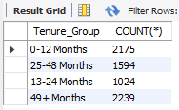

Python Analysis
Continued in PythonAnalysis.ipynb

